

**Access to WOIS**

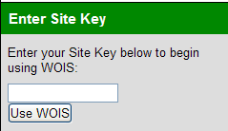

1. Go to [www.wois.org](http://www.wois.org) and Log on with your **Site Key** & click **Use WOIS.**



1. Log in with your **User ID** and **Password**
2. Click **Log in**